Output 1

Write a Program to create a simple calculator program that takes user input for two numbers and an operator(+,-,\*,/) and performs the corresponding arithmetic operation using conditional statements.

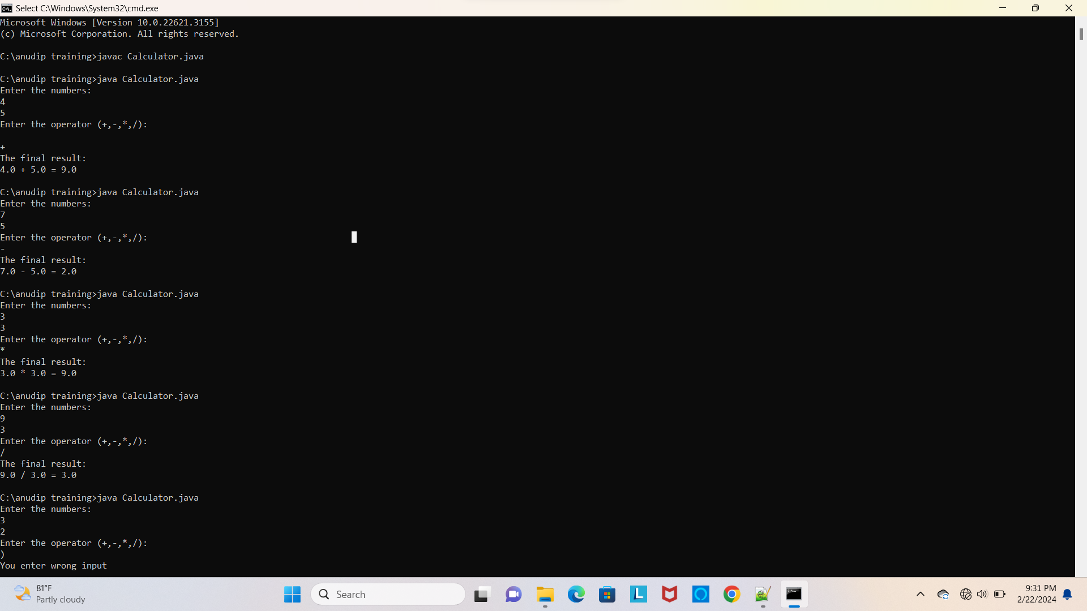

Output 2

Create a class named book with attributes title, author, ISBN, and price. Include methods to get and set the attributes

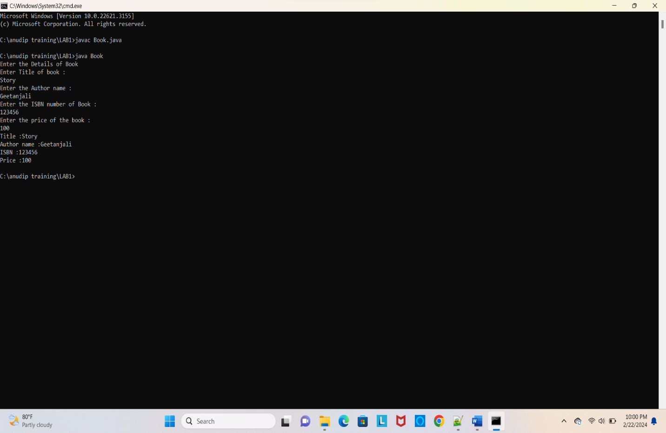

Output 3

Create a class named Employees with attributes name, employeeID, designation, and salary.

include a method calculateBonus() that returns 5% of the salary as bonus.

